**S3-Static Website Hosting**

It means if you have static website with few html page (or) image we can host the whole thing using Amazon S3 and share out a URL to show others also.

Go to the AWS S3 service dashboard

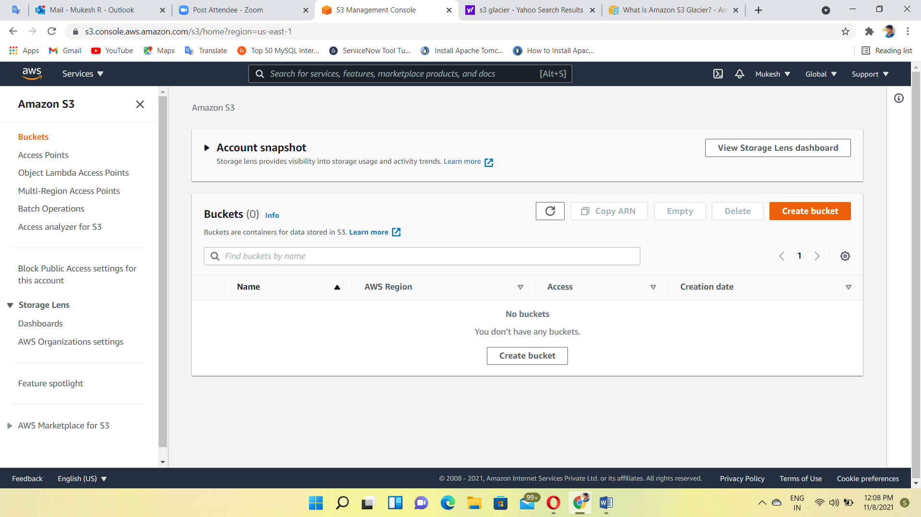

Create a bucket with globally unique name

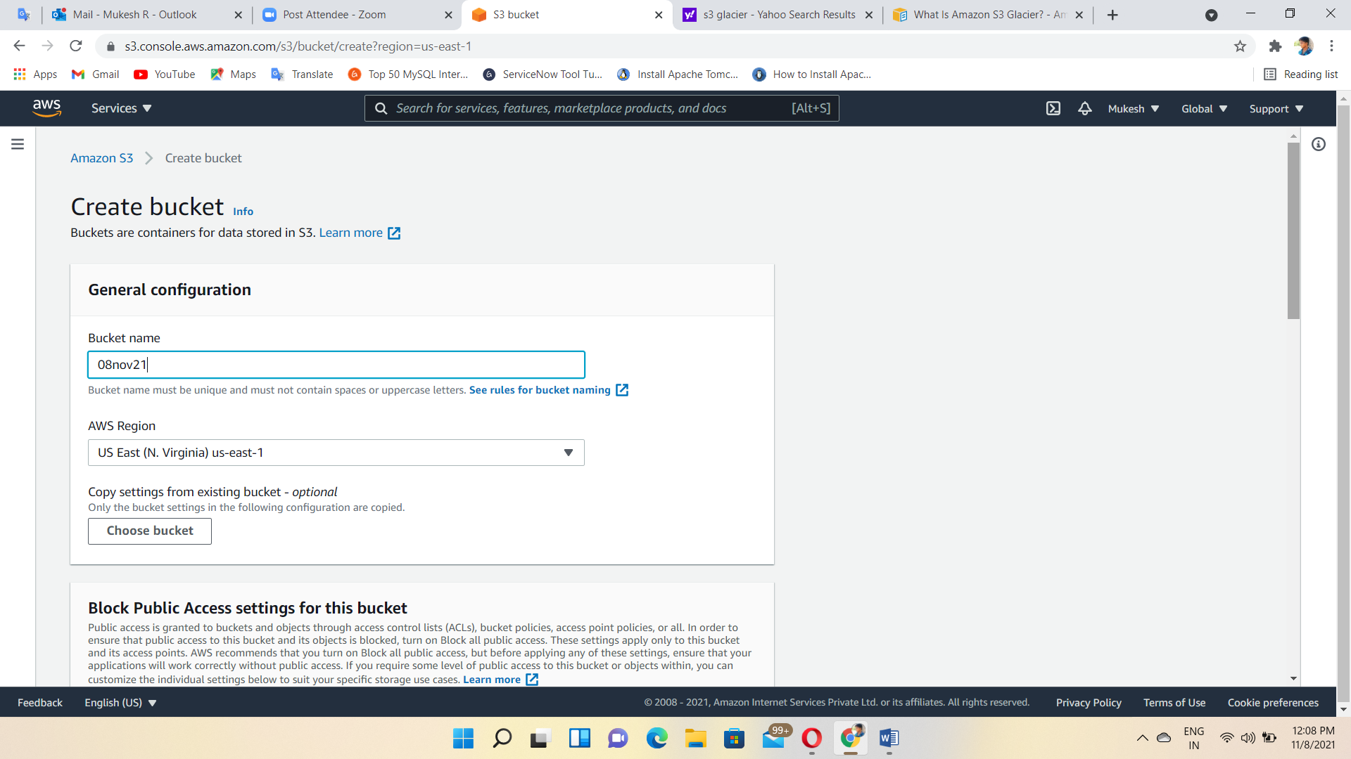

Enabling the Bucket versioning

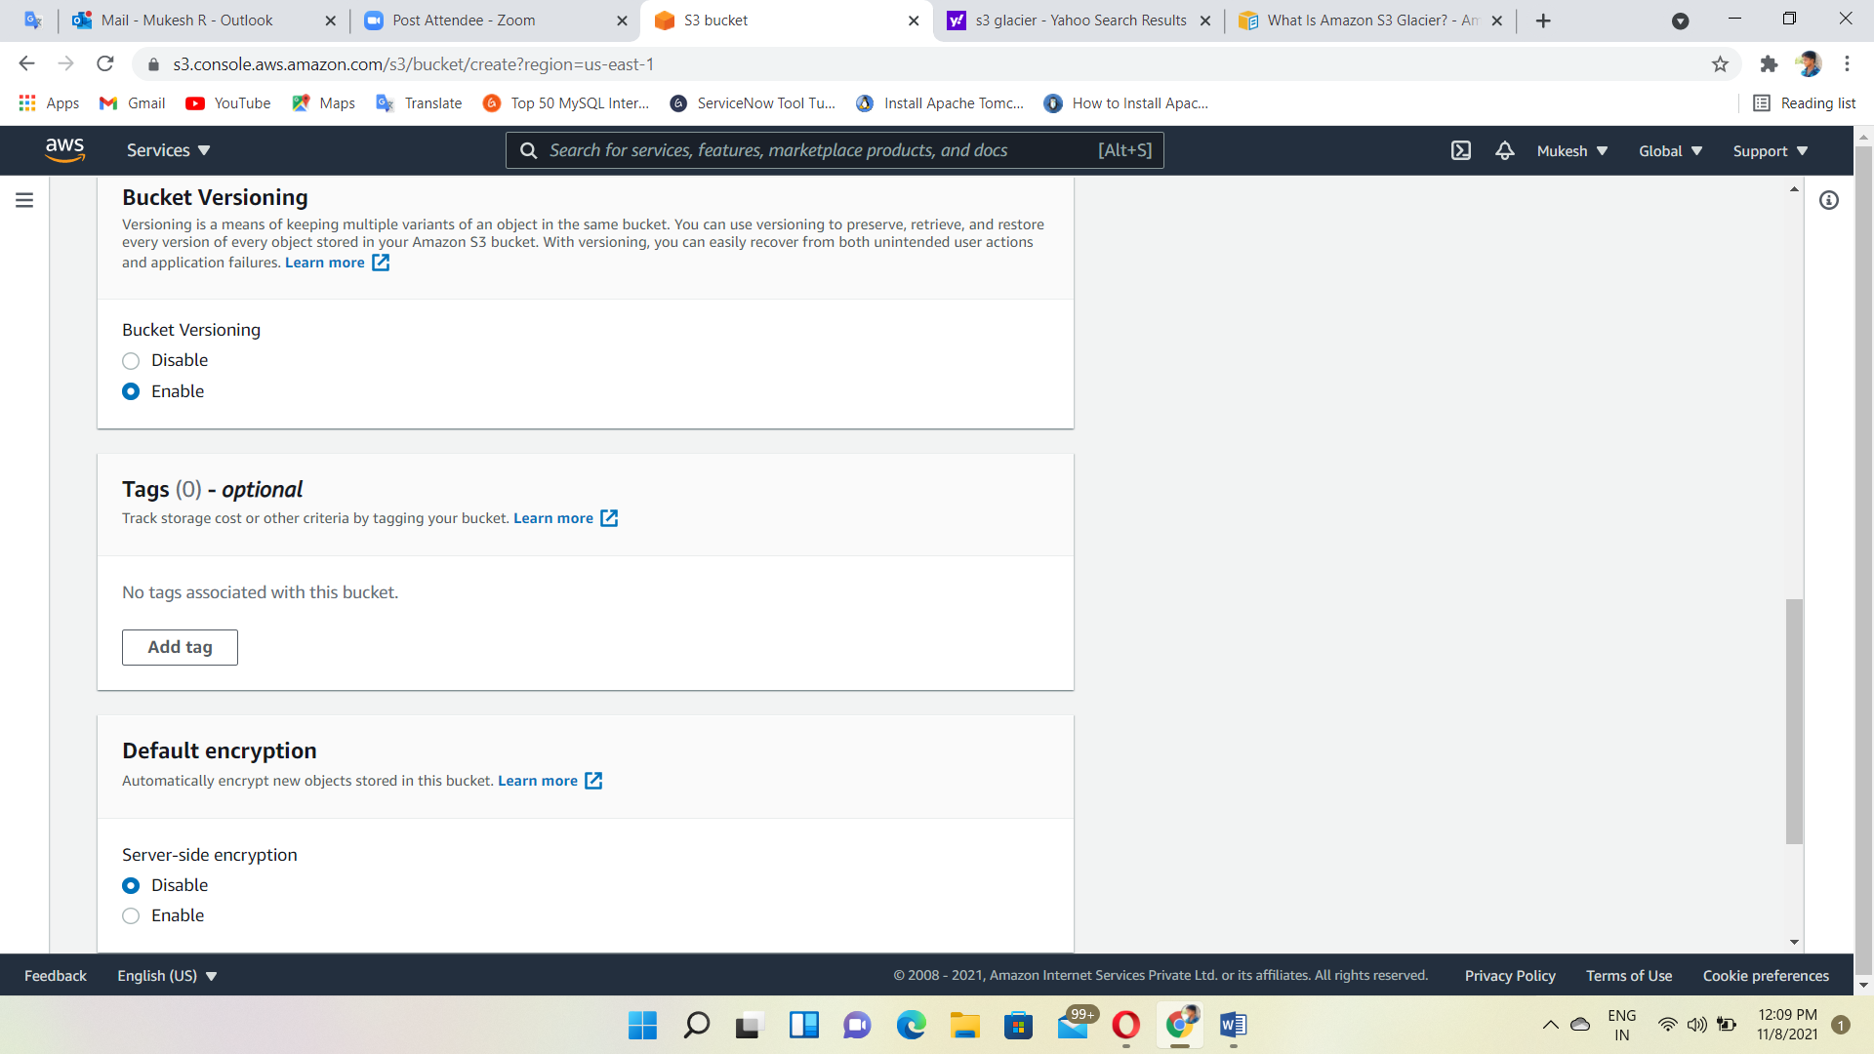

Bucket Created

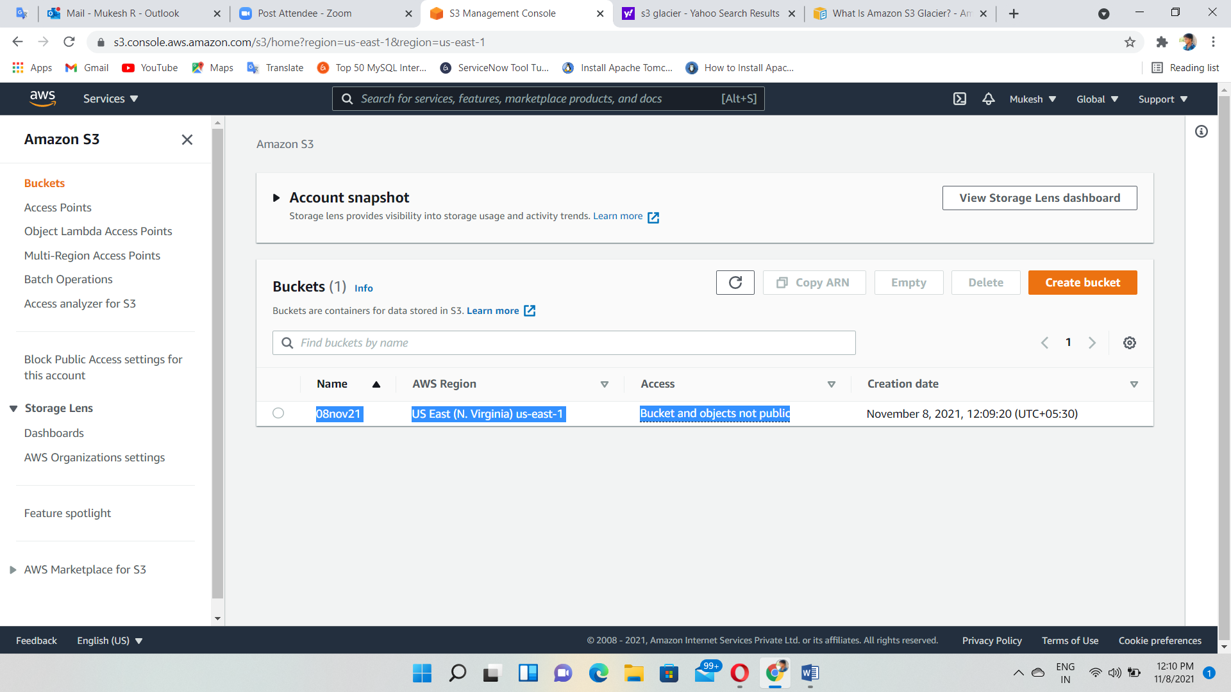

Disabling the Block public access

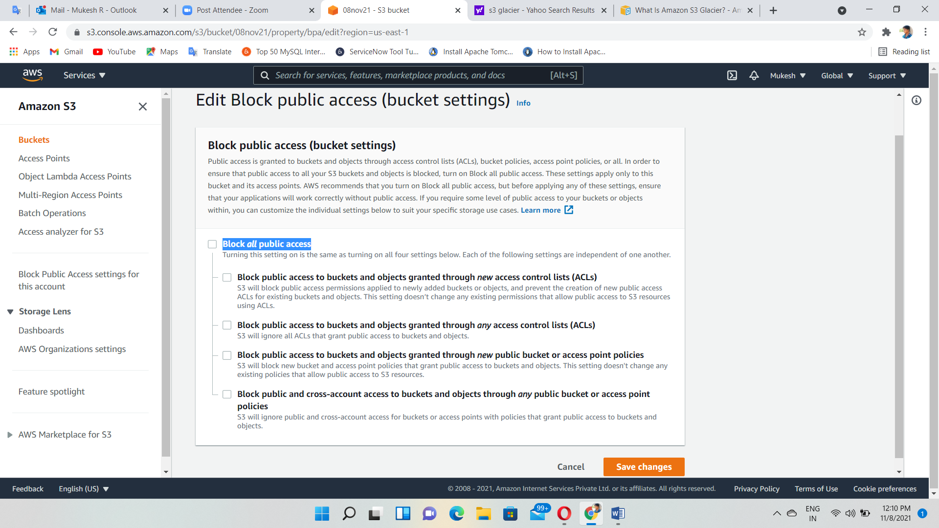

Static website hosting- click edit

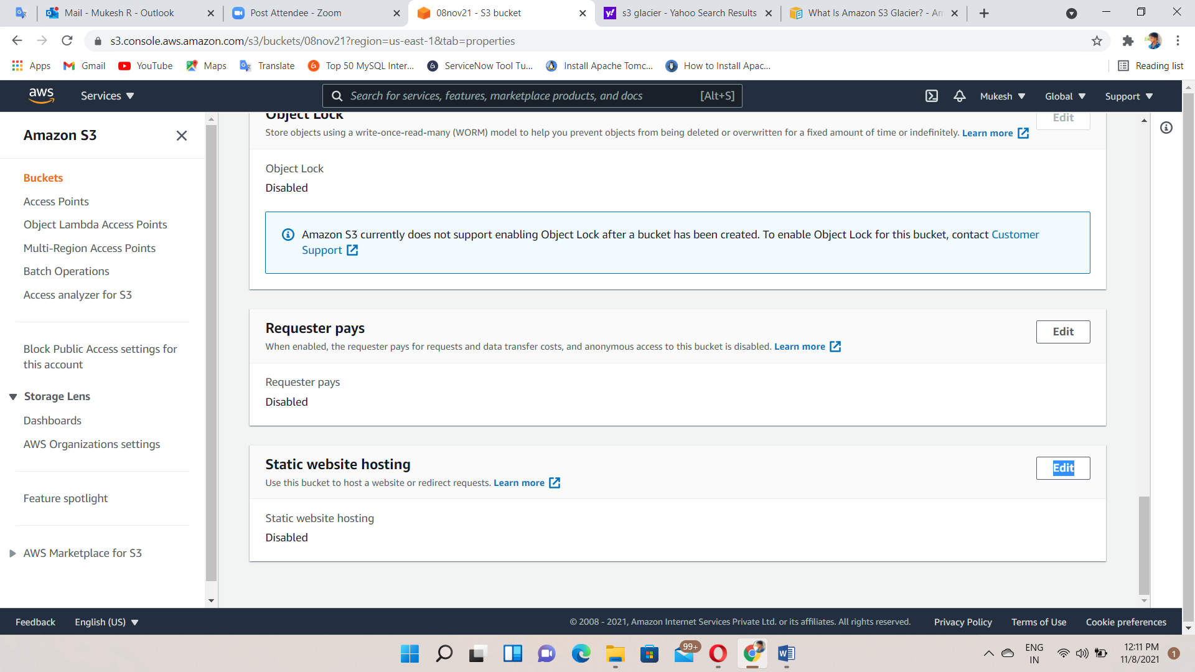

Enabling the static website hosting and entered to the document type

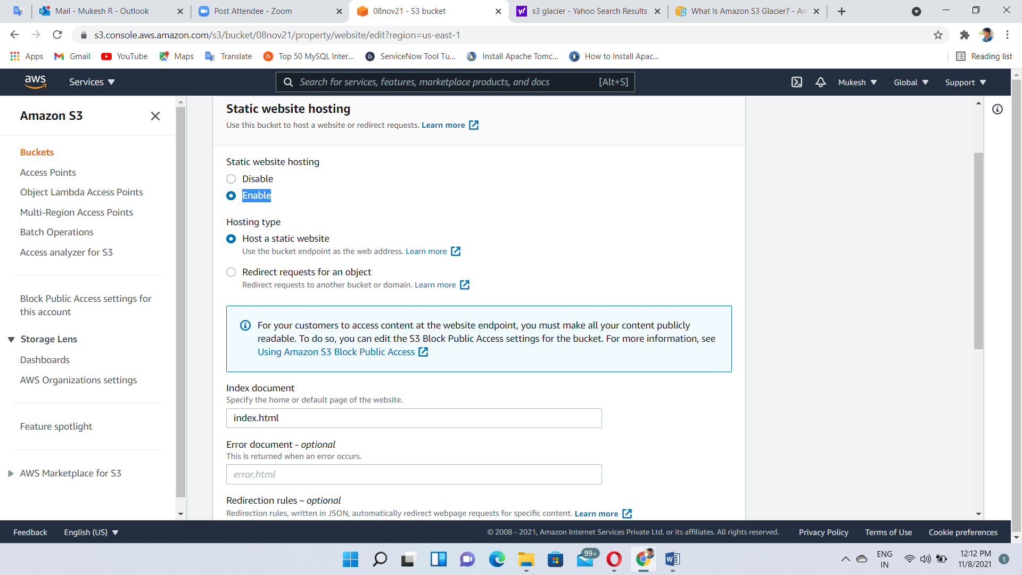

Set the permission for viewing the files in the bucket to public, anyone with the link to the index.html file can view the static website.

Generate the Bucket policy

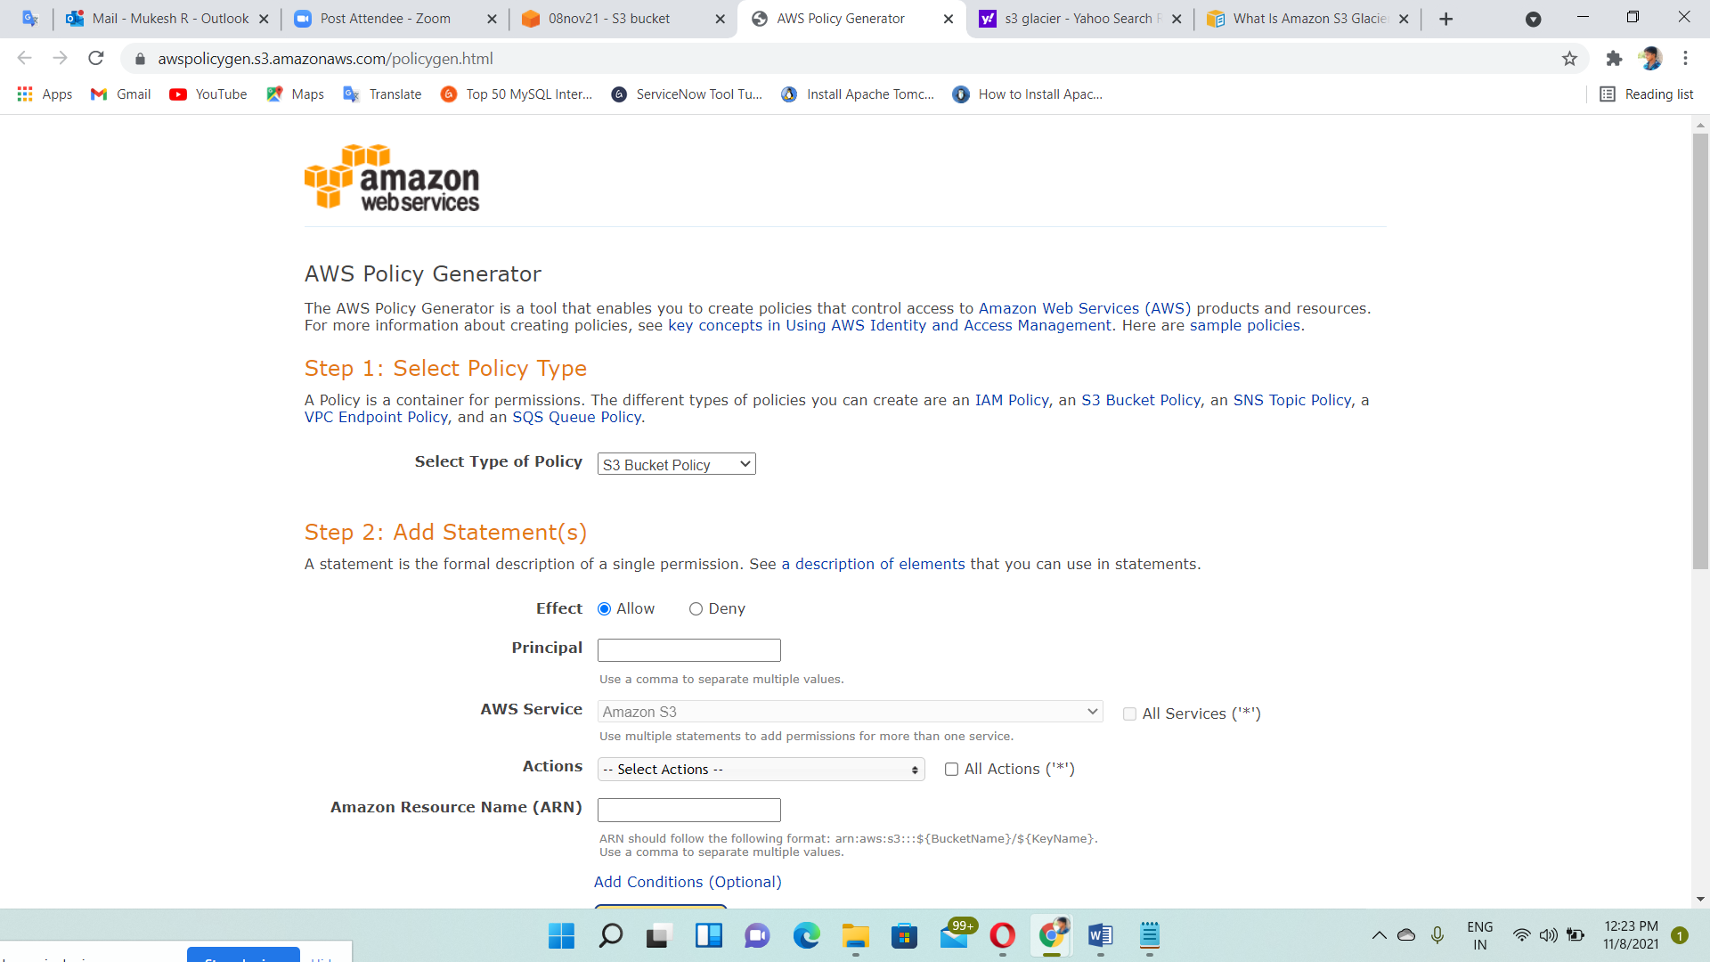

Copy the policy

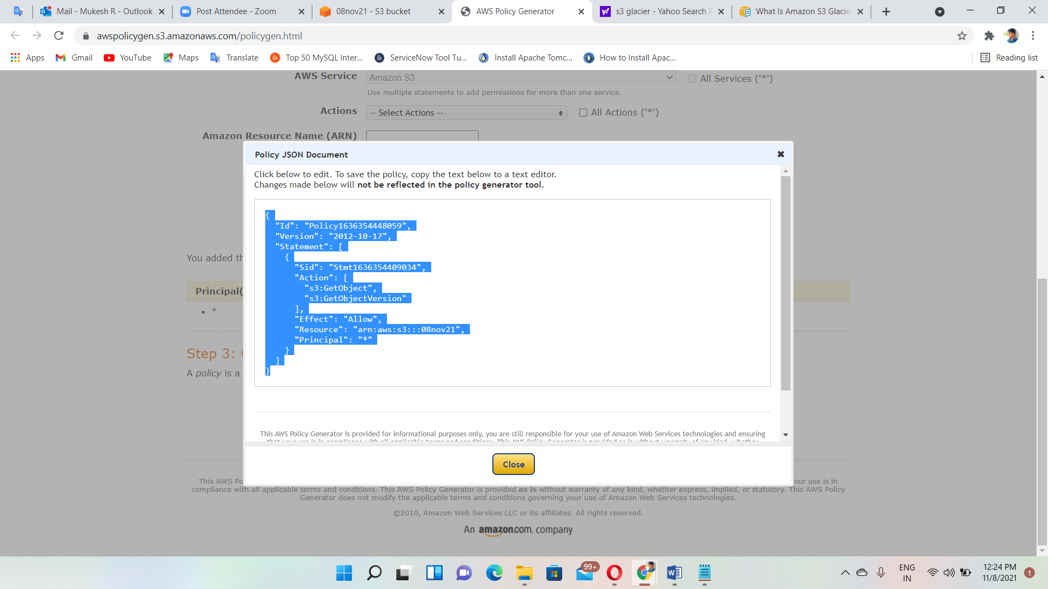

Paste and upload the policy

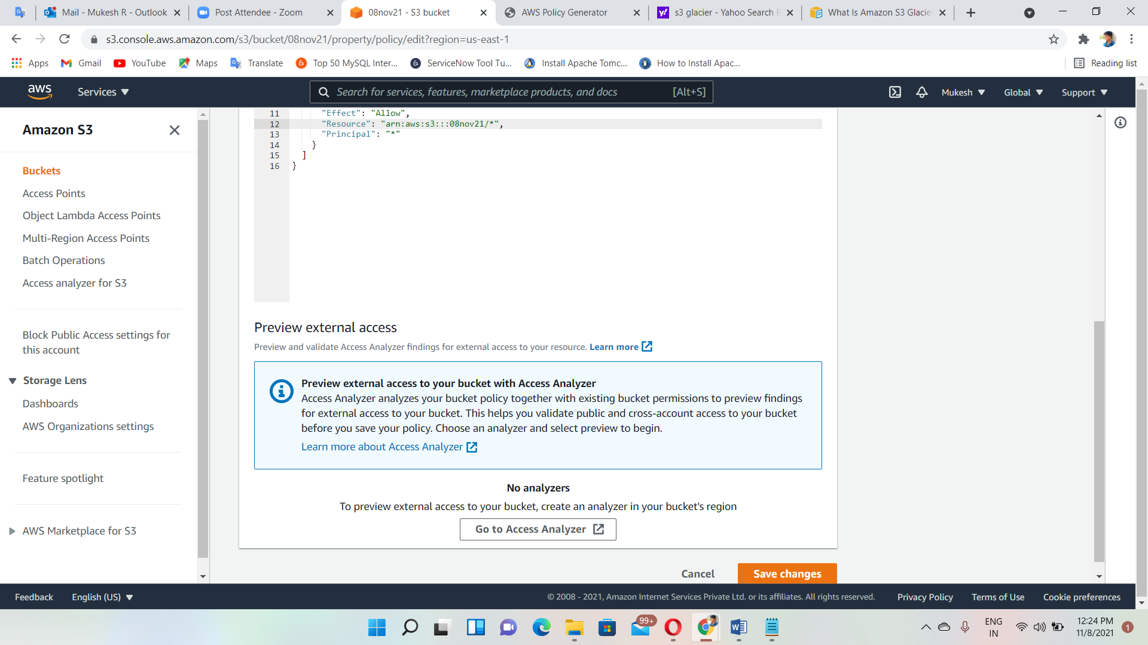

Uploading the files we want inside the bucket

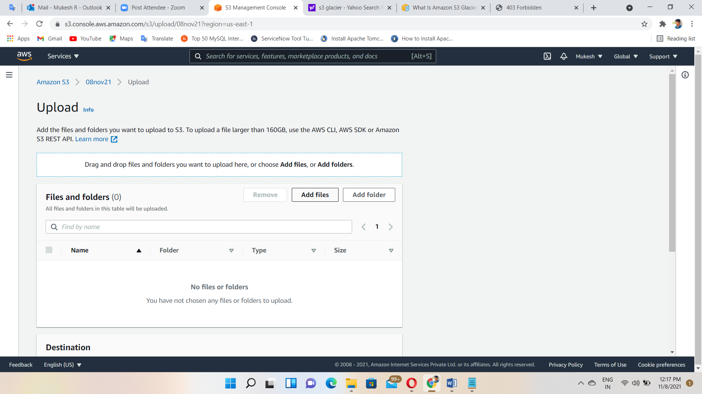

uploaded

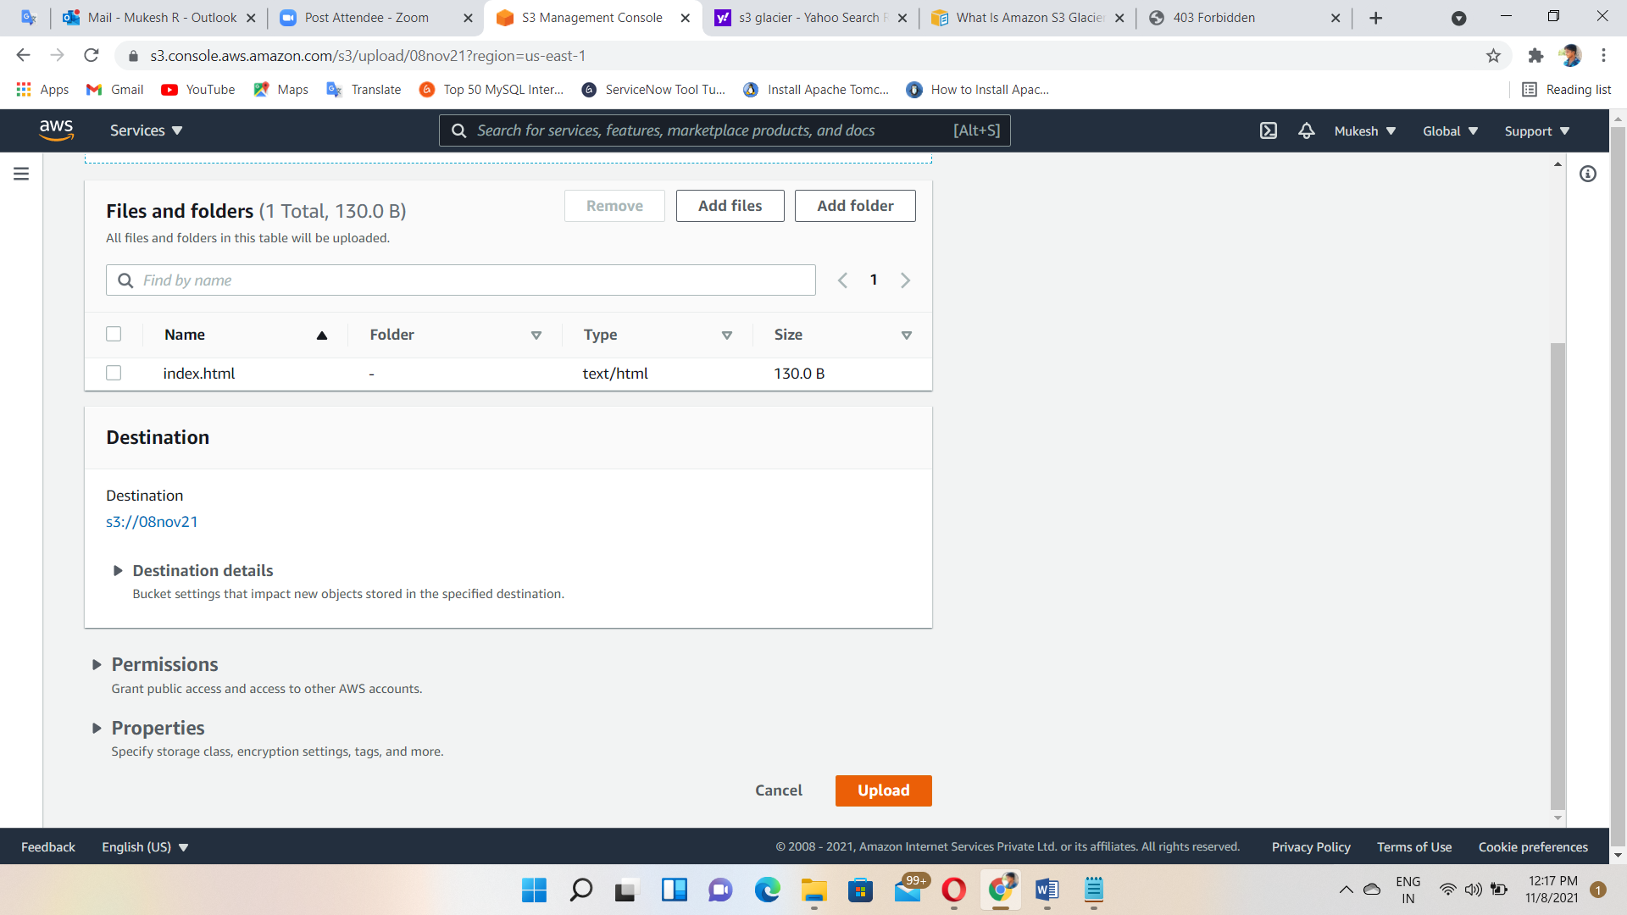

Copy the bucket website URL

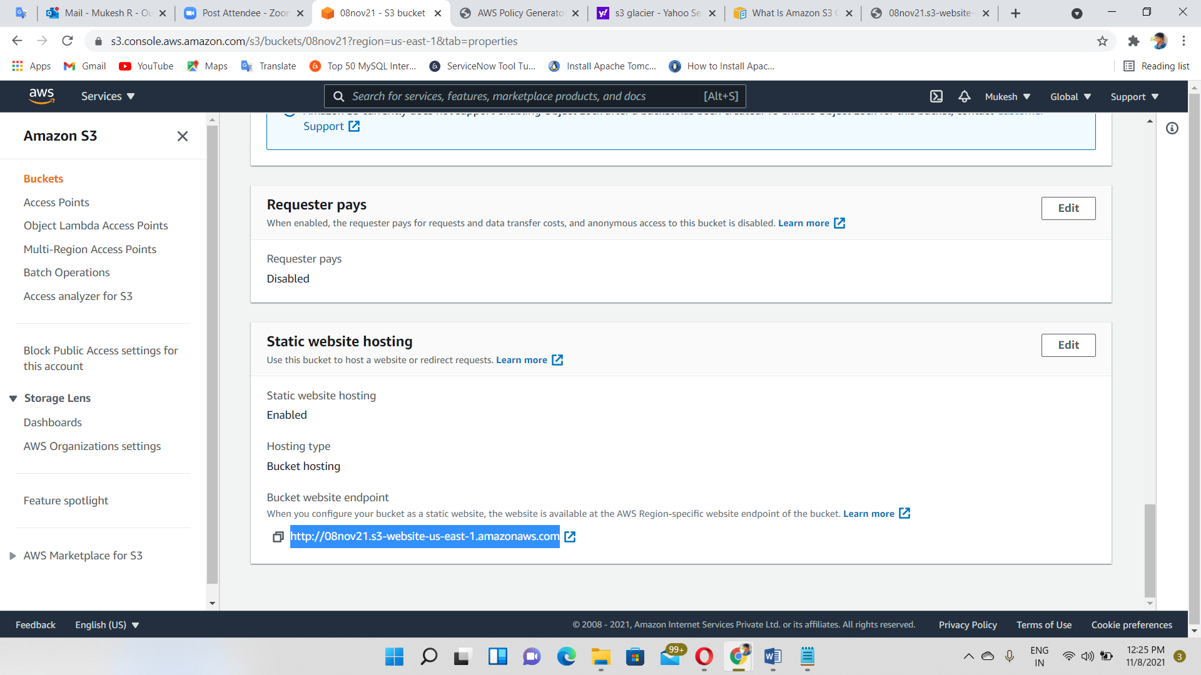

Output🡪finally, accessed our static website hosted on s3. Because, we already set our object permissions and public access. So, anyone with the link can see our website.

